**User Manual of AI Personal Finance Tracker**

**Group 52**

Login & Registration Page

* After launching the application, you will be taken to the BuckBrain Login Page.
* Users need to enter Username and Password in the page.

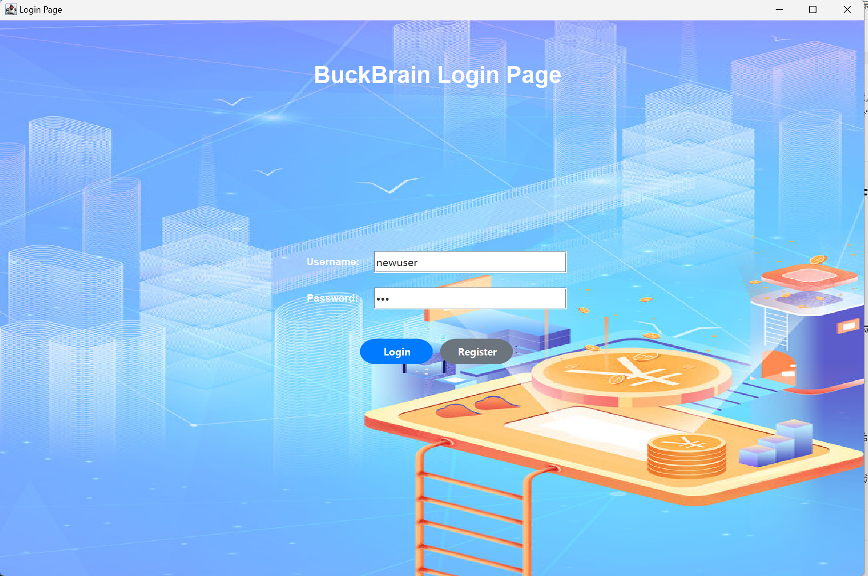

* Click the blue button Login to log into the system; click the grey button Register to enter the registration page to create a new account.

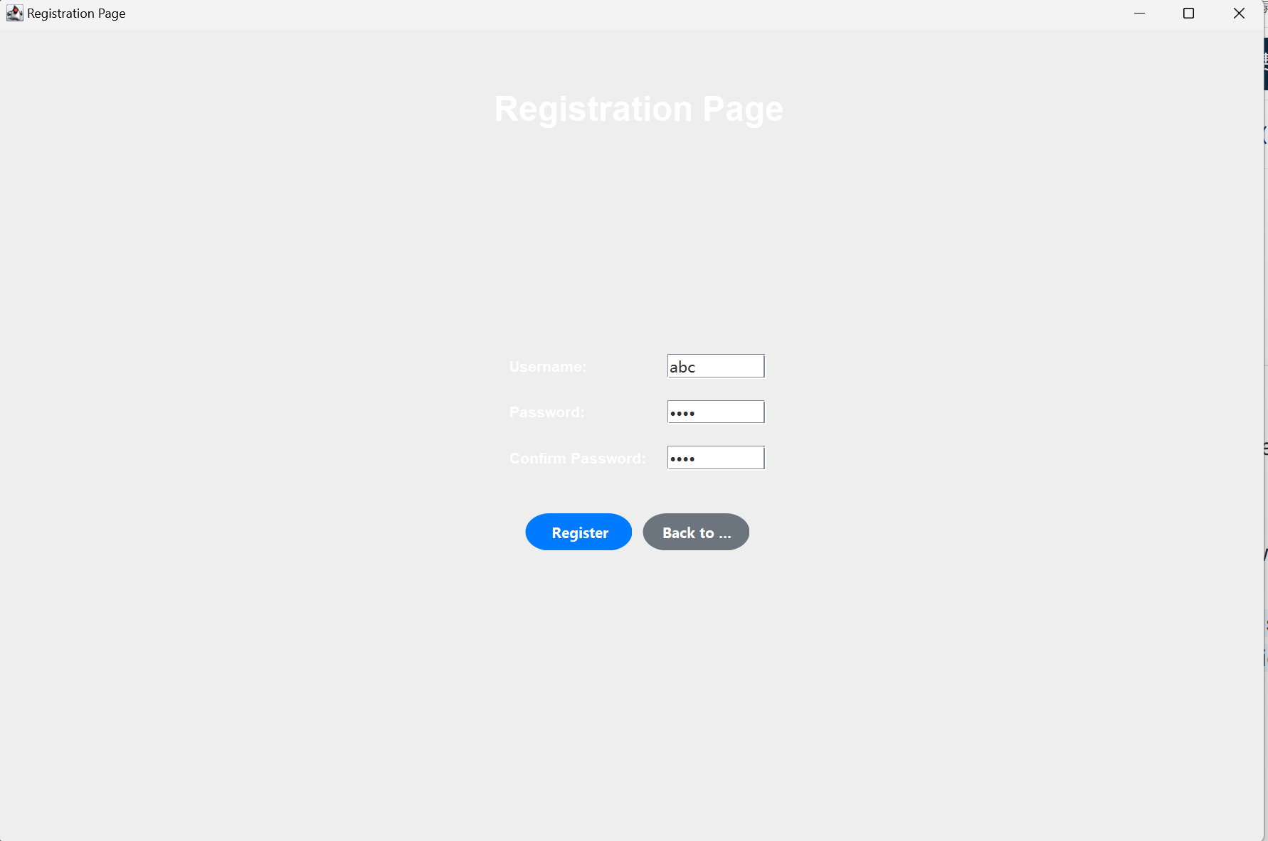

Functional Module

2.1 Dashboard

* Displays account balances, recent transactions, weekly spending activity bar graphs and spending statistics pie charts.

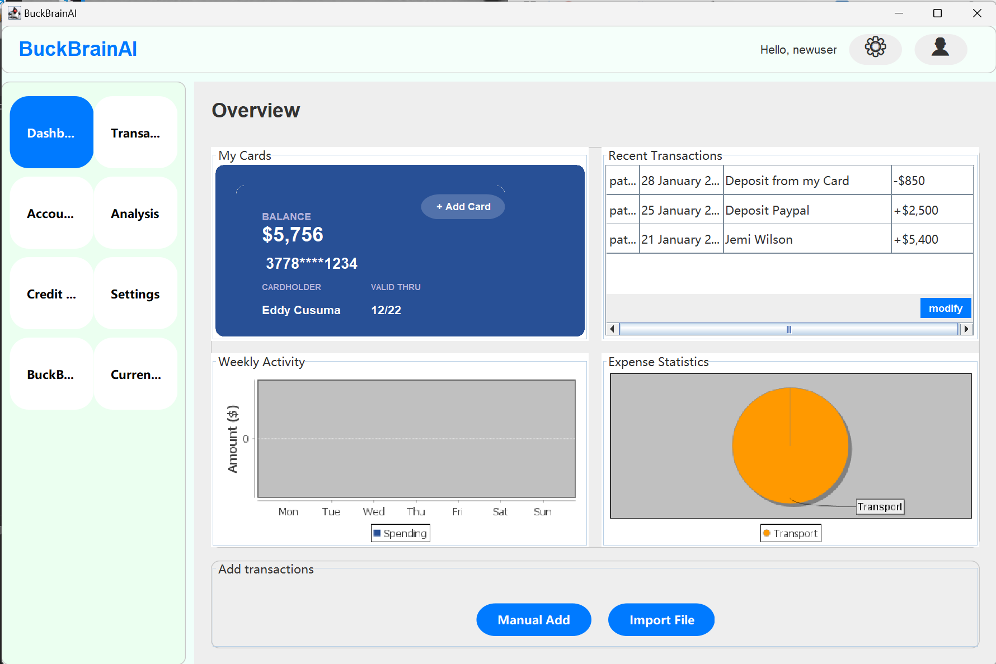

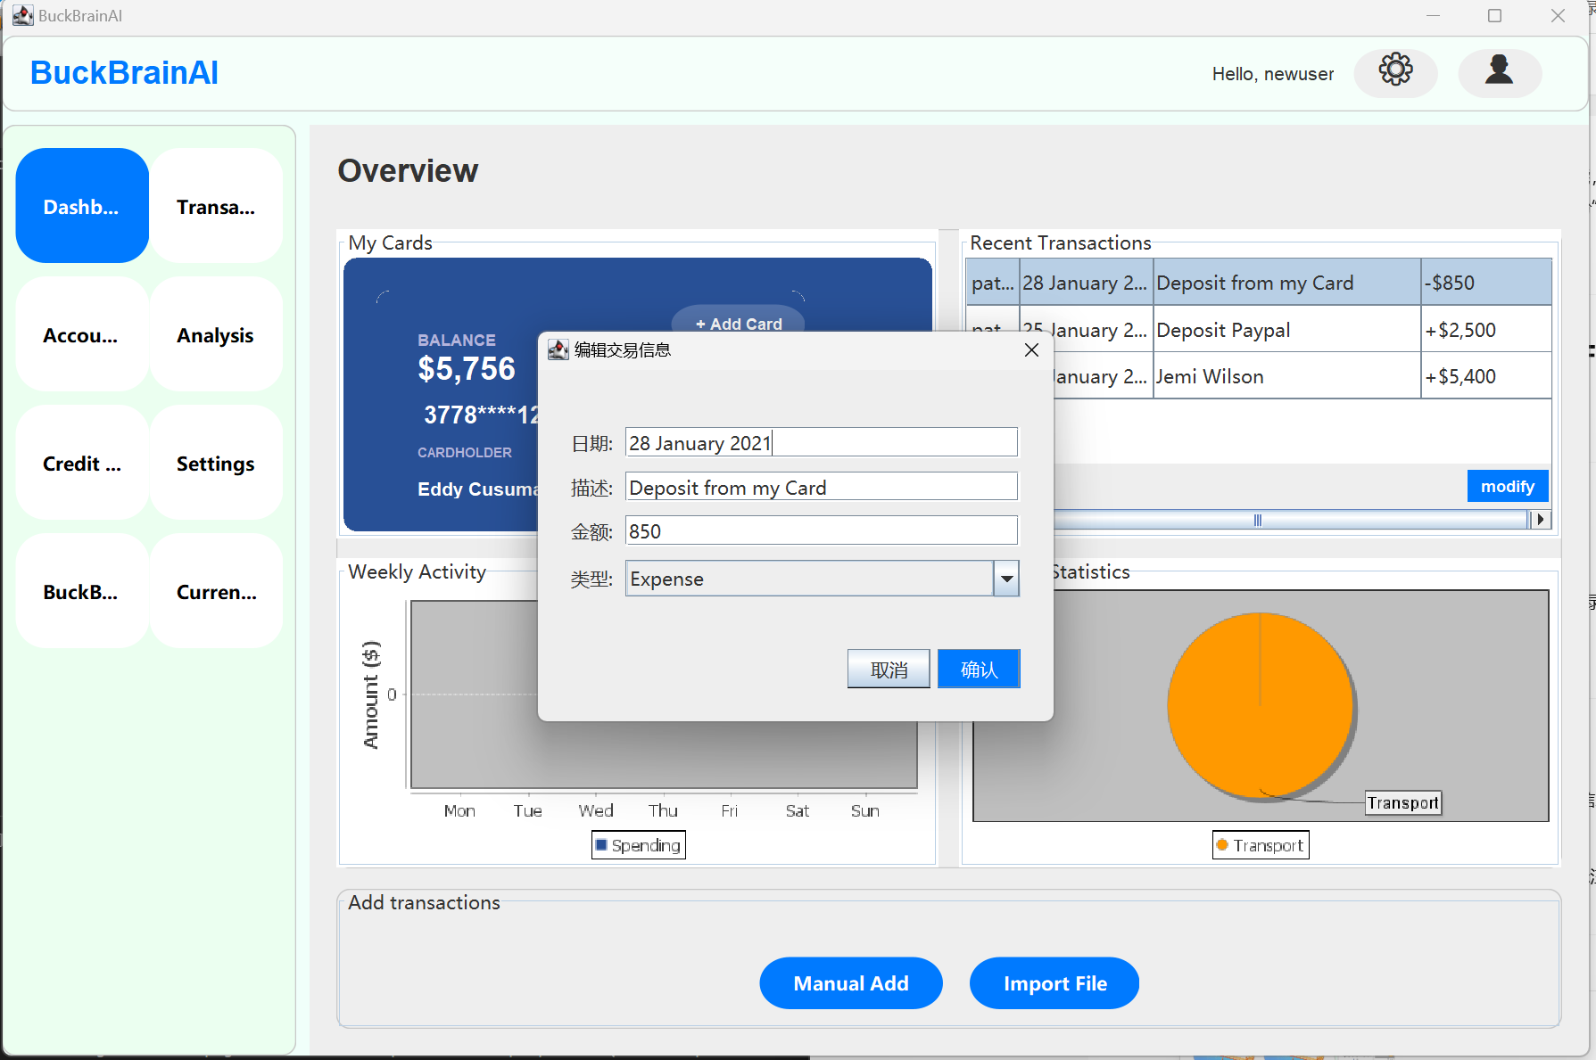

* Manual Add and Import File buttons are available at the bottom.

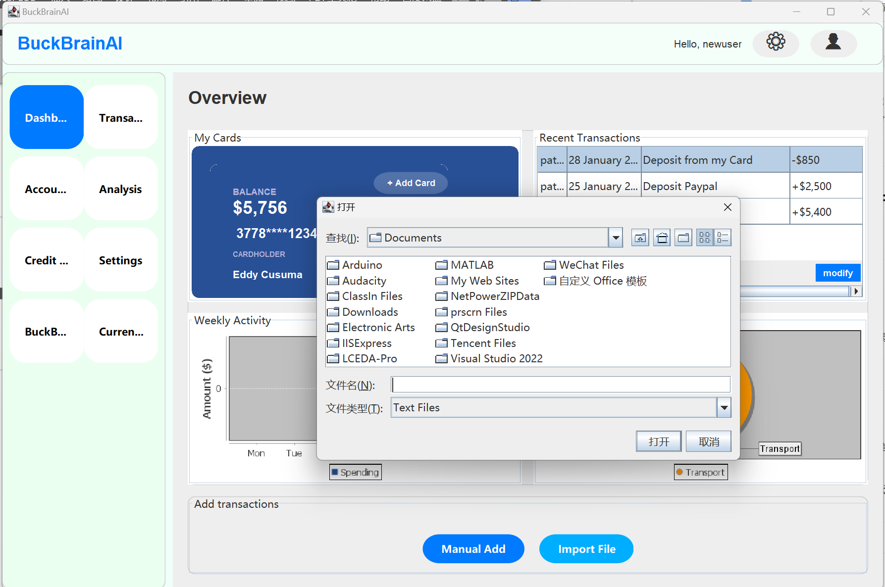2.2 Transactions Module

* Categorized to show all transaction records, including: All Transactions(Show all transactions), Income( Show only income), Expense( show only expenses)
* The table contains fields such as Transaction Description, ID, Type, Card, Time, Amount, etc. It supports paging.

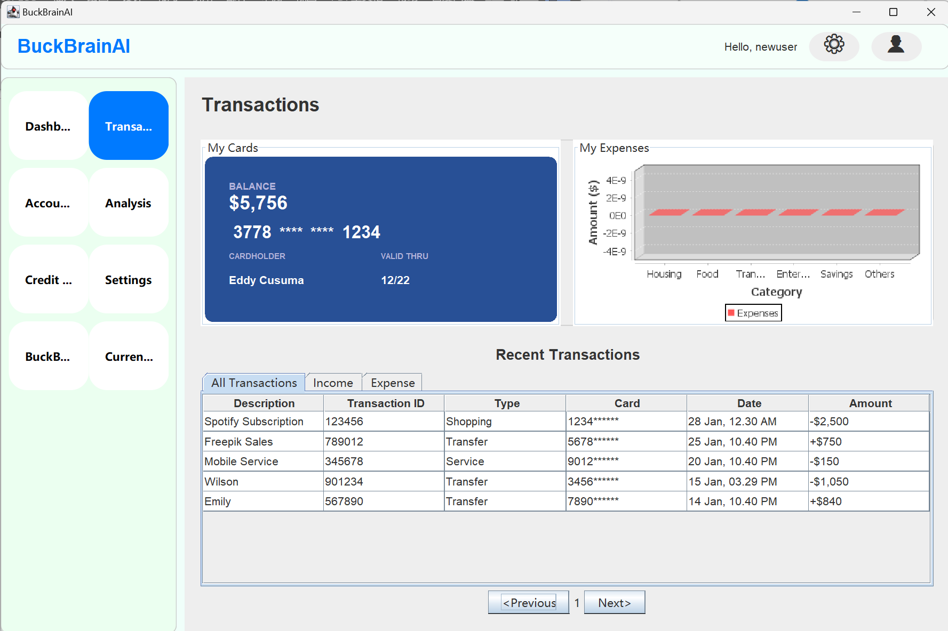

2.3 Account Information Module

* Displays summary account information: Account summary, Monthly Income / Monthly Expenses, Transaction Status (Pending / Completed).
* The chart in the bottom right corner shows Weekly Overview (weekly spending trends).
* Manual Add and Import File shortcuts are still available at the bottom.

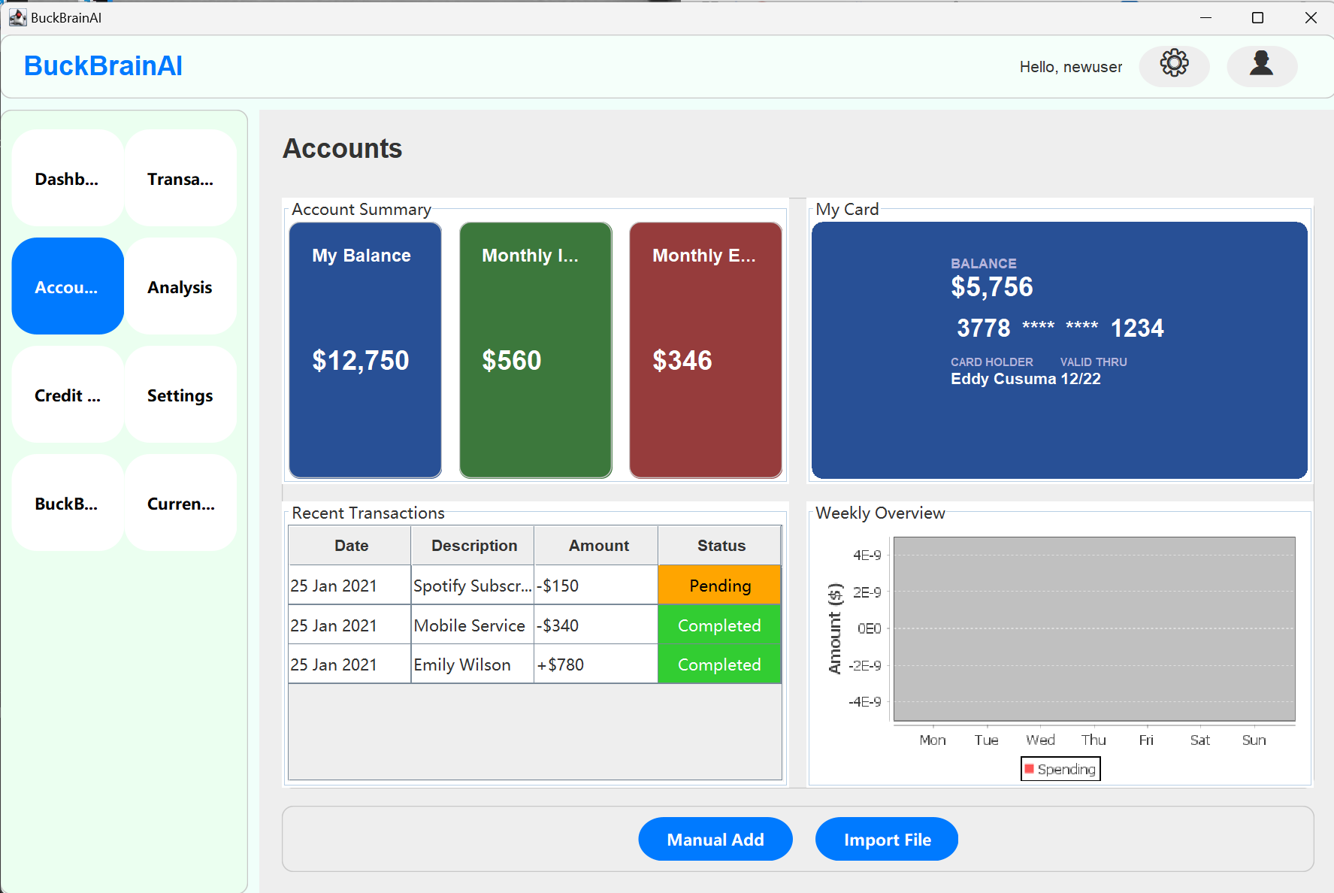

2.4 Analysis of consumption trend

* Display annual income and expenditure trends and monthly income and expenditure trends.
* Textual summary of AI analysis results
* Provide Generate Report button to generate report

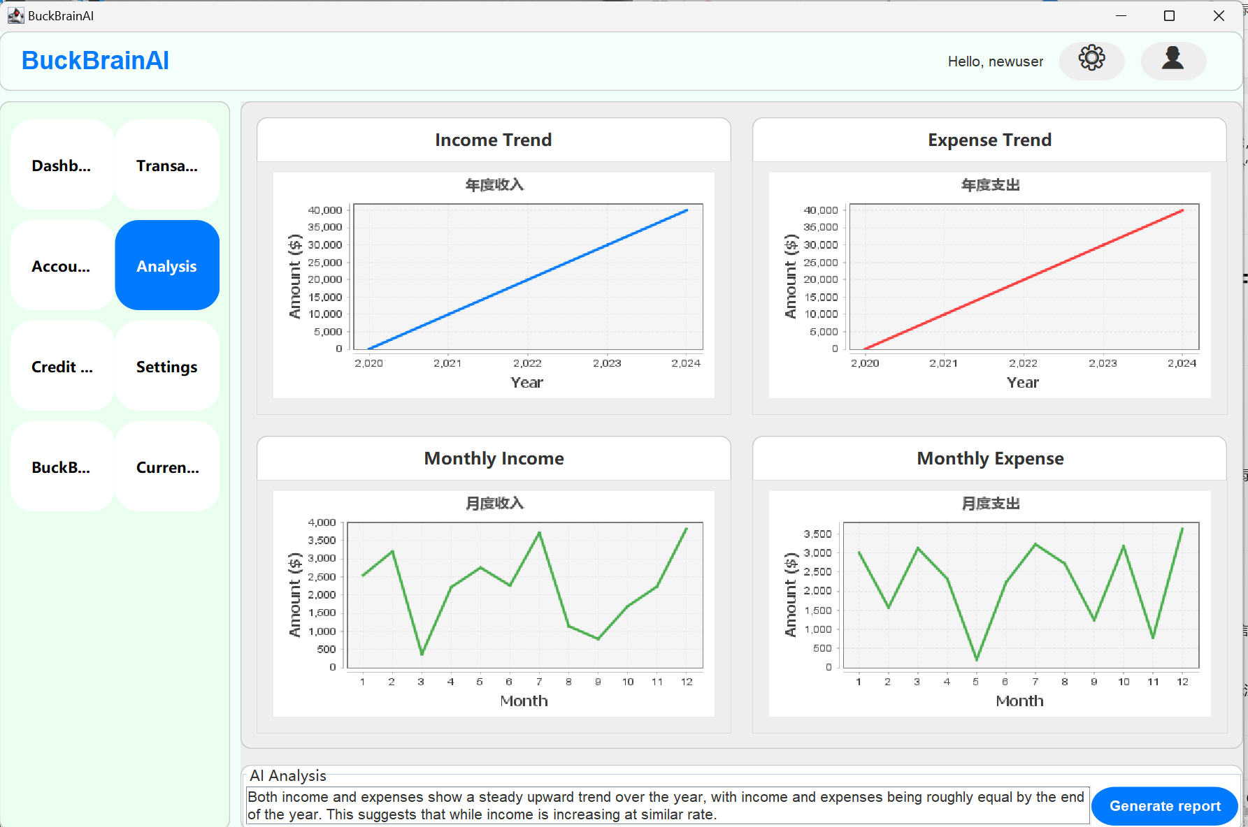

2.5 Credit Card Management

* On the left side is a list of card information (type, bank, card number, cardholder) and on the right side is a pie chart of card account statistics.
* The lower form supports adding new cards, which requires filling in the card type, card number, cardholder name, and expiration time.

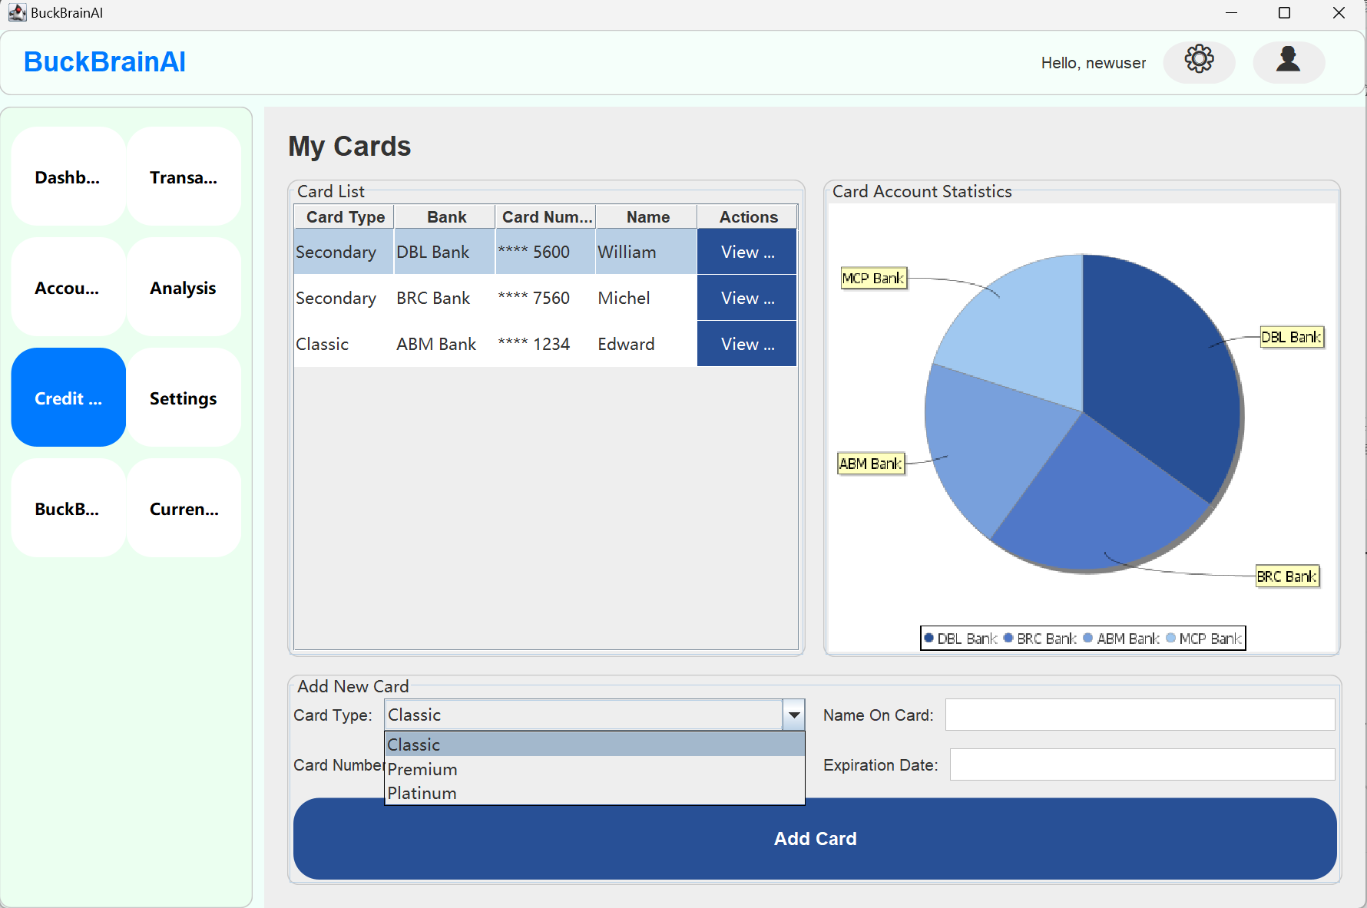

2.6 Setup Page

* The Profile page allows users to view and modify personal information such as name, email and date of birth.

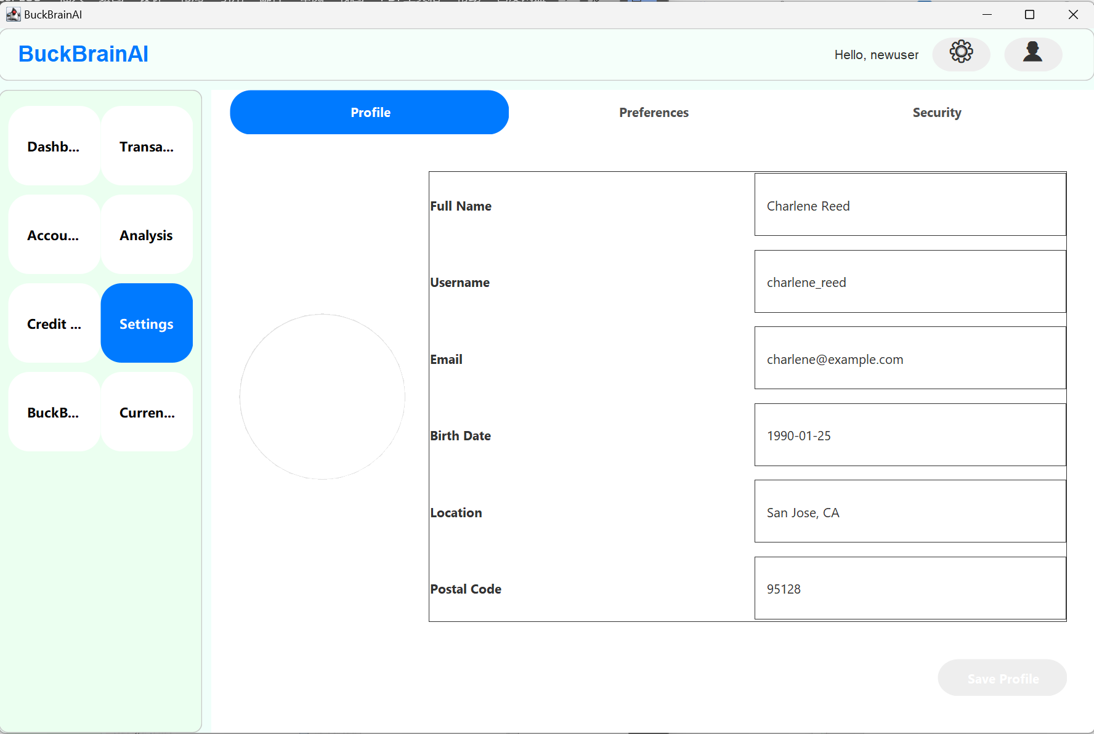

* The Preferences page provides options for preferences such as currency, time zone, notifications, and budget limitis.

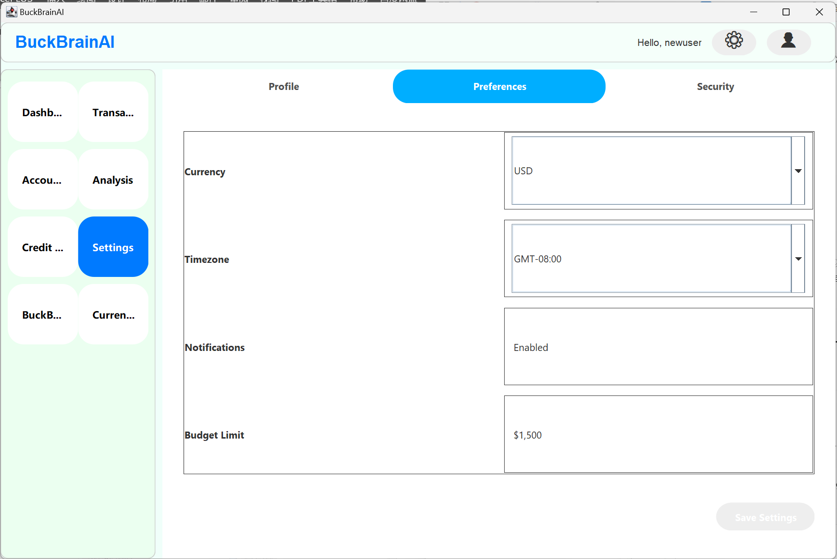

* The Security page displays the account password status, secondary authentication settings, and configuration of password questions.

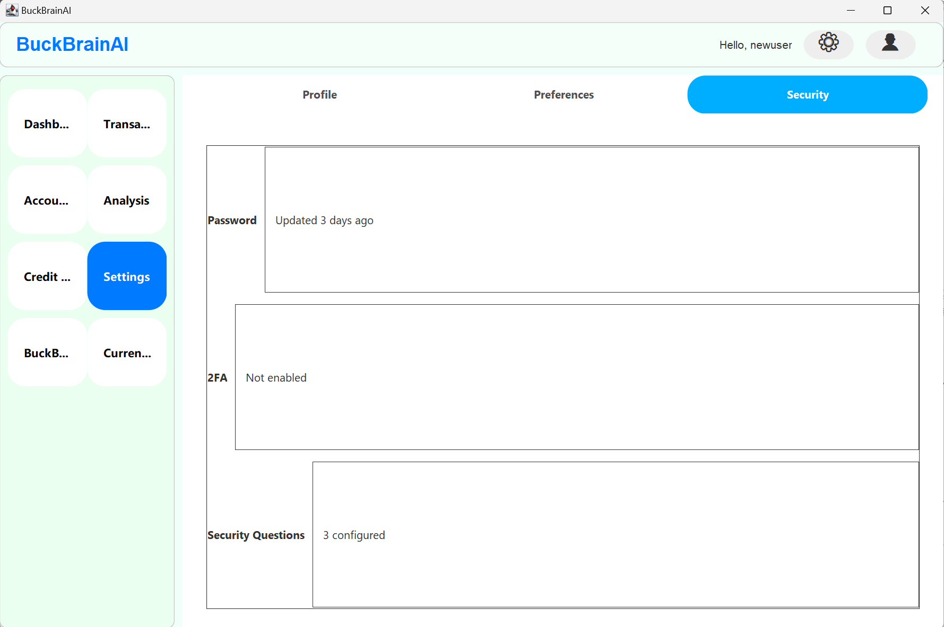

2.7 BuckBrain AI Assistant

* In the module, users can type in questions like ‘How can I save money?’ as if they were chatting. and the system generates AI suggestions.

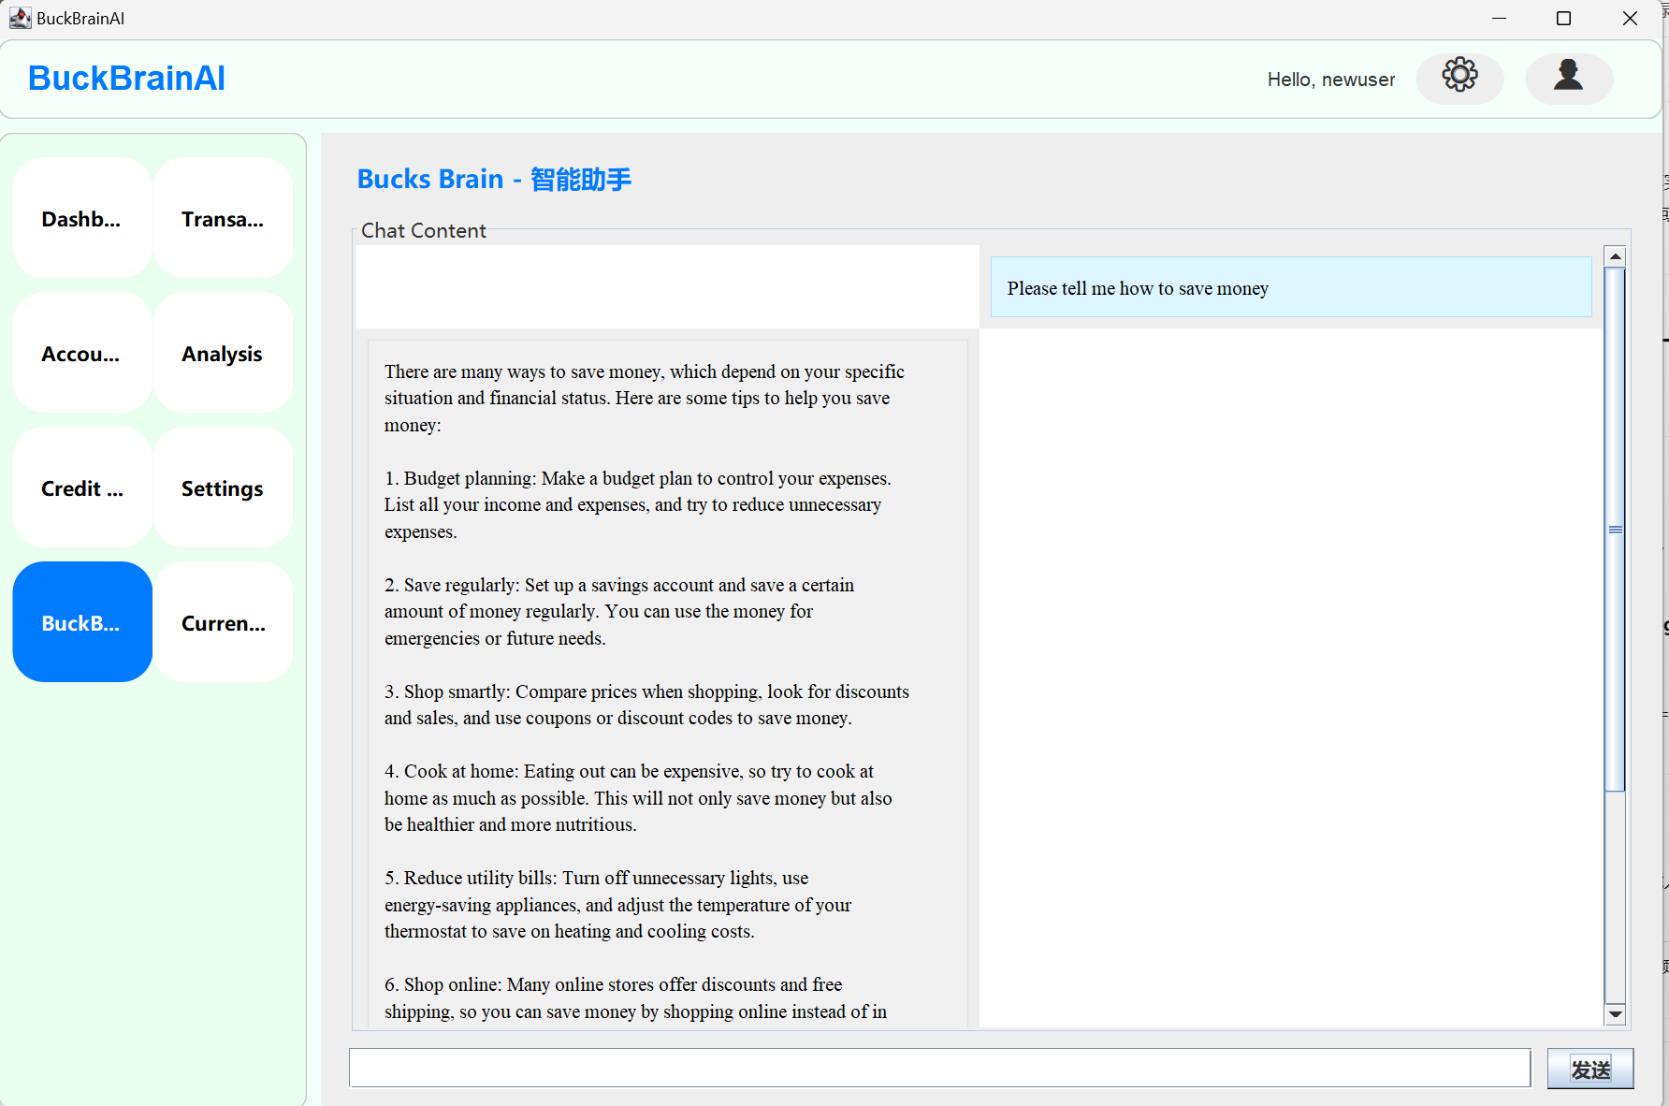

2.8 Currency Converter

* The Currency Converter page supports quick conversion between RMB, USD, EUR and HKD currencies and displays the results.

